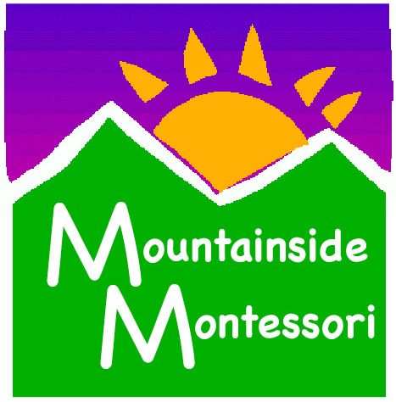

ELEMENTARY GUIDE POSITION

Mountainside Montessori School, Marshall, VA
Mountainside Montessori School is currently accepting applications for an Elementary Guide (ages 6-12).
The Elementary Guide must be motivated and flexible with a strong desire to work with children of all ages and their families. The ideal candidate is passionate about Montessori and dedicated to fostering a lifelong love of learning.
We are excited to start the 2015-16 school year at our new 10-acre campus, which will allow us to serve children from birth through ninth grade, as well as offer programs to the community at large. Our new building and campus will allow us to blend beautiful indoor and outdoor spaces and will reflect our mission of environmental stewardship, sustainable agriculture, and free play in nature. Located at the foothills of the Blue Ridge Mountains, the new site is surrounded by some of the most beautiful horse farms in the country, is steeped in American history, and is just one hour away from our nation’s capital.
For more information about our school, please go to our website: www.mountainsidemontessori.com
Please send cover letter and resume to:
Edel Kunkel
4206 Belvoir Rd. Marshall, VA 20115
Edel@mountainsidemontessori.com
Phone: (540) 253-5025

